The estimated outline of this document would be based on Fundamentals of Engineering (FE), INDUSTRIAL AND SYSTEMS CBT Exam Specifications

A. Six sigma  
B. Management and planning tools (e.g., fishbone, Pareto, QFD, TQM)  
C. Control charts  
D. Process capability and specifications  
E. Sampling plans  
F. Design of experiments for quality improvement  
G. Reliability engineering

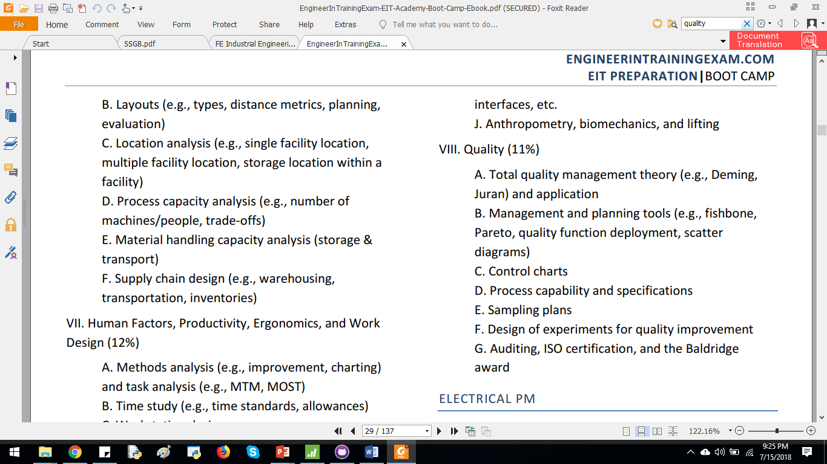

# Recap of Applied Statistics

## Regression Analysis ([Automobile specifications data](https://support.minitab.com/en-us/datasets/graphs-data-sets/automobile-specifications-data/))

|  |  |
| --- | --- |
| Combined MPG  19.25  25.50  39.55  29.50  41.20  30.15  17.80  22.25  28.00  15.25  28.70  49.65  49.85  42.20  24.70  15.25  21.15  23.70  33.15 | Retail ($1000)  31.3  31.0  35.6  22.1  26.0  16.2  26.9  28.9  40.0  78.0  19.3  24.2  19.0  26.7  22.7  42.0  26.4  27.7  14.4 |

Checking the relation between two variables



Regression Analysis

|  |
| --- |
| **Regression Analysis: Combined MPG versus Retail ($1000)**  Analysis of Variance  Source DF Adj SS Adj MS F-Value P-Value  Regression 1 415.6 415.64 4.25 0.055  Retail ($1000) 1 415.6 415.64 4.25 0.055  Error 17 1662.6 97.80  Total 18 2078.3  Model Summary  S R-sq R-sq(adj) R-sq(pred)  9.88953 20.00% 15.29% 3.22%  Coefficients  Term Coef SE Coef T-Value P-Value VIF  Constant 39.51 5.44 7.26 0.000  Retail ($1000) -0.347 0.168 -2.06 0.055 1.00  Regression Equation  Combined MPG = 39.51 - 0.347 Retail ($1000)  Fits and Diagnostics for Unusual Observations  Combined Std  Obs MPG Fit Resid Resid  10 15.25 12.43 2.82 0.56 X  X Unusual X |

**Residual Plots for Combined MPG**

